

**LocAdoc**

**User Interface Design Document**

**Version 1.0**

**Prepared by: Abhi Jay Krishnan**

**Kim Hyeocheol**

**Rivaldo Erawan**

**Durrah Afshan**

Table of Contents

1. Introduction 1

1.1 Reference 1

2. User flow design 1

2.1 User flow diagram 1

2.2 User flow description 1

3. UI designs 2

3.1 Login 2

3.2 Signup 3

3.3 Reset password 4

3.4 Home Screen 5

3.5 Home screen (searching area) 6

3.6 Home screen (browser file) 7

3.7 Home screen (file operations) 8

3.8 PDF viewer 9

3.9 Main Menu 10

3.10 Settings 11

3.11 Change password 12

3.12 About 13

# Introduction

The purpose of this document is to provide a complete description of the user interface that would-be part of the completed LocAdoc application.

The main scope of this document is to:-

* + Get a clear understanding on how user will transit between different activities.
  + Get an overview of each interface design.

To readers may wish to refer to software requirement specification sheet for further details on system functionalities.

## Reference

The design in the document is created using Pencil (An open-source GUI prototyping tool).

URL: <https://pencil.evolus.vn/>

# User flow design

## User flow diagram

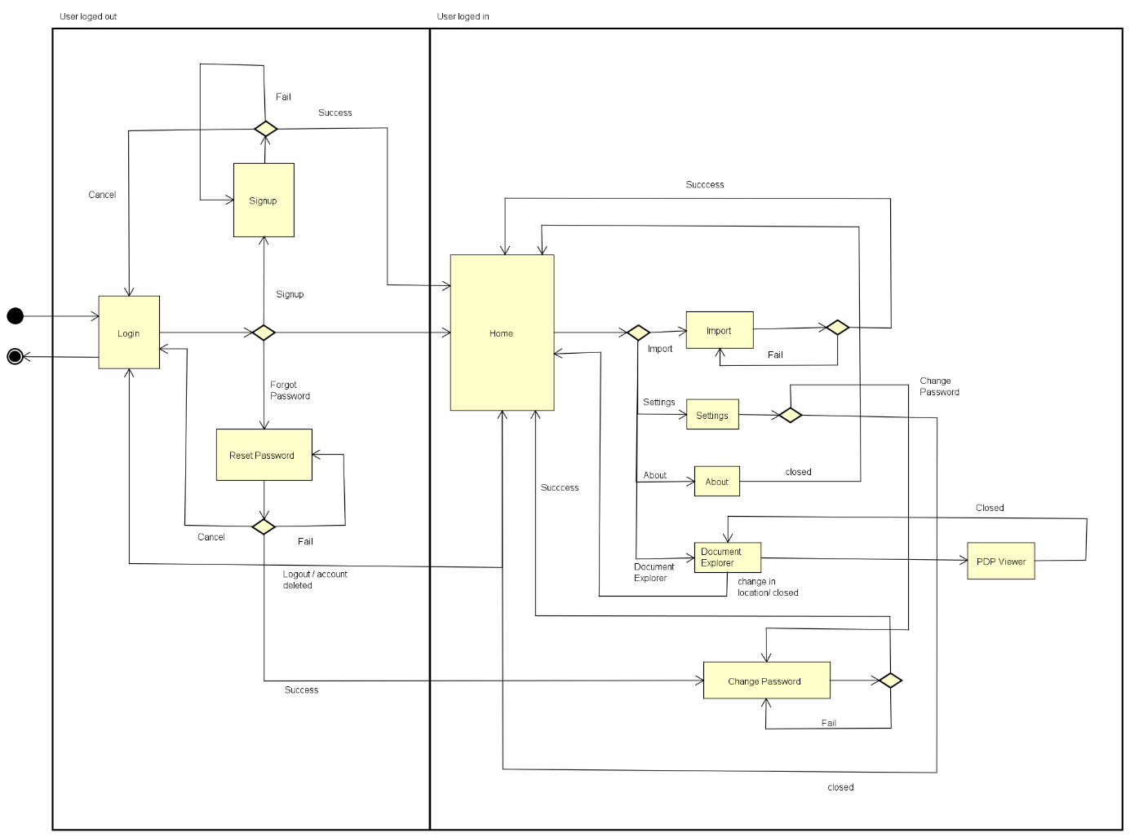

Figure 1: User flow diagram

## User flow description

User start from login screen, which has 3 functionalities namely login, forget password (reset password) and signup. The user returns to login screen if they logout from application or cancel signup or rest process.

Once the login is successful the moves on to the home screen which is the central location that links to all system functionalities such as location map, brows file based on area, import document and menu with settings, help and about functions.

Setting have options the change password and to change user details. The user may wish to delete account from settings.

Document explorer is based on the area the user is currently in and the user may wish to view the currently available files or delete them.

# UI designs

## Login

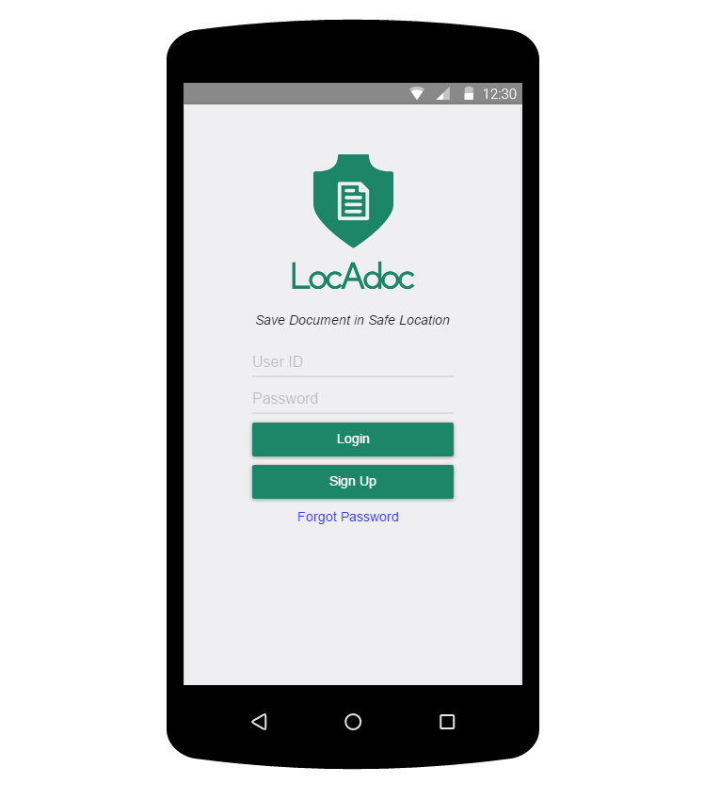

Figure 2: Login screen

Login screen will have user has the option to login, signup. He may also wish to create his own account using username and password. The login screen also leads to reset password feature.

## Signup

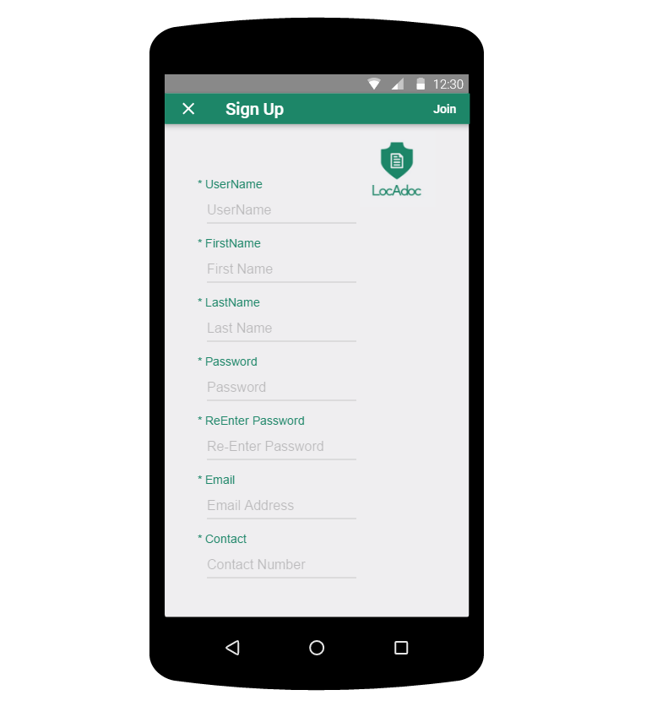

This is the signup form where the user can fill the above information and the system will signup the user for the services.

## Reset password

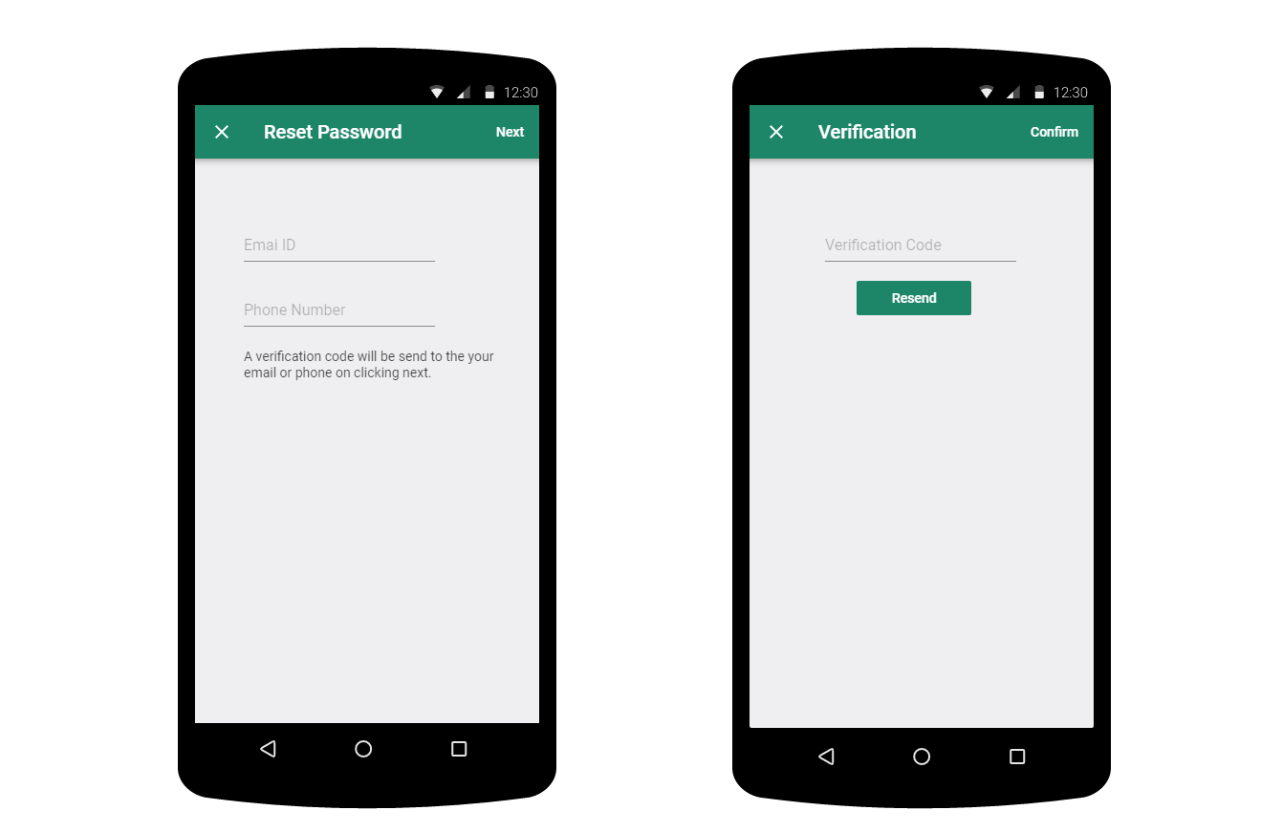

The user will fill up the password reset form and on clicking next a verification code will be send to the email or phone. The second screen the user need to enter the verification code.

## Home Screen

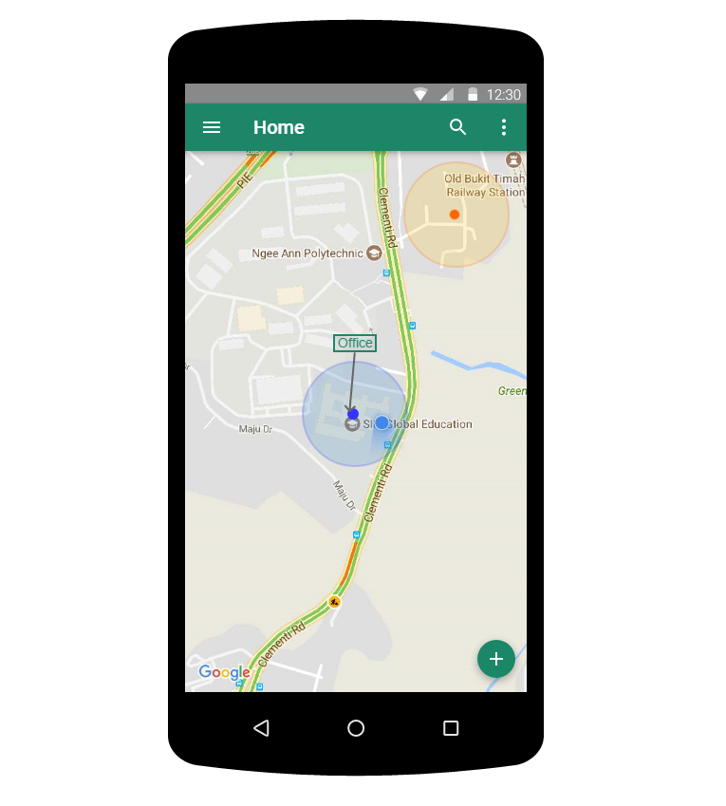

On logging in successfully the user will enter this screen where the user gets to see a map with his current location and the areas near him. The top bar has a menu icon on the left and a search bar.

He may click on the blue dot that represent the area to open up all the files in that location. The plus symbol below leads to adding a new document to the current location.

## **Home screen (searching area**)

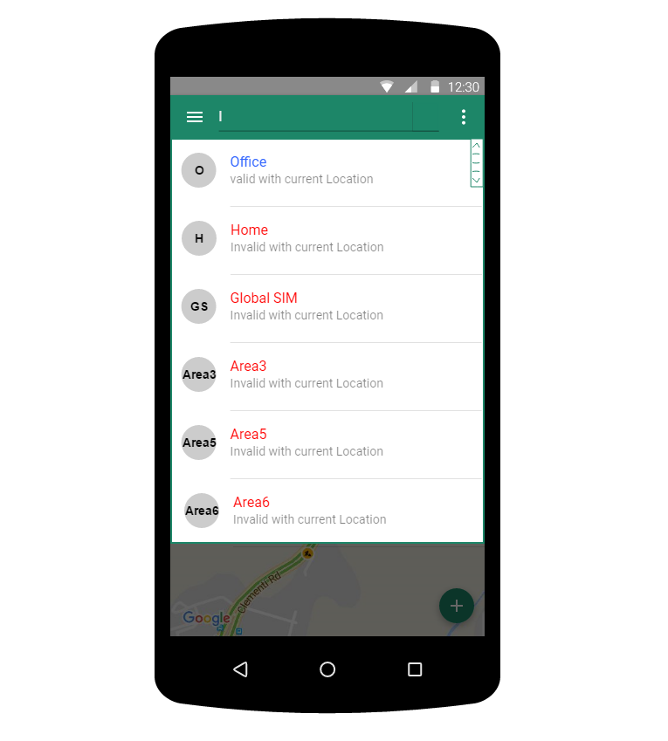

The user can search all the area from the search bar but can only access the files under that area if he/she is in that location.

## **Home screen (browser file**)

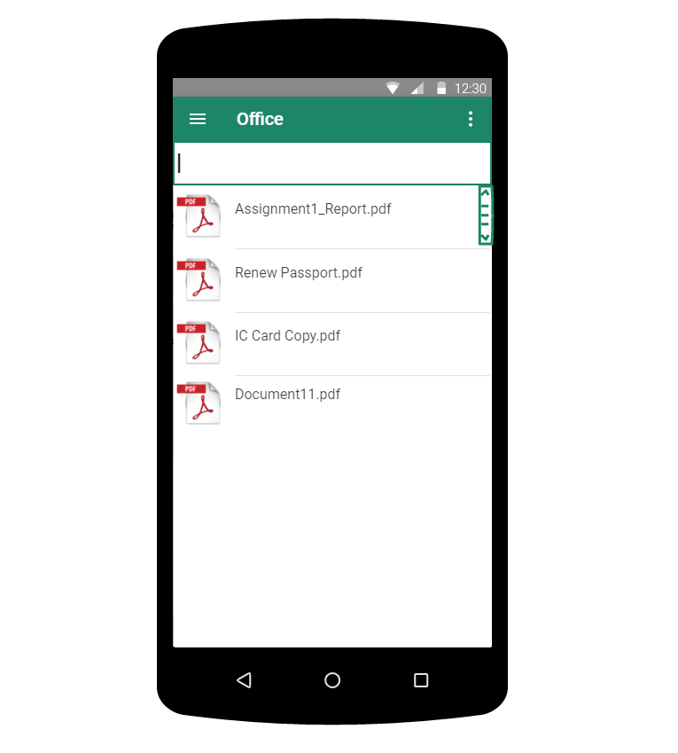

The app will list out all the files that is available in the current area. This screen can be approached by tapping the location pointer on the home screen map.

## Home screen (file operations)

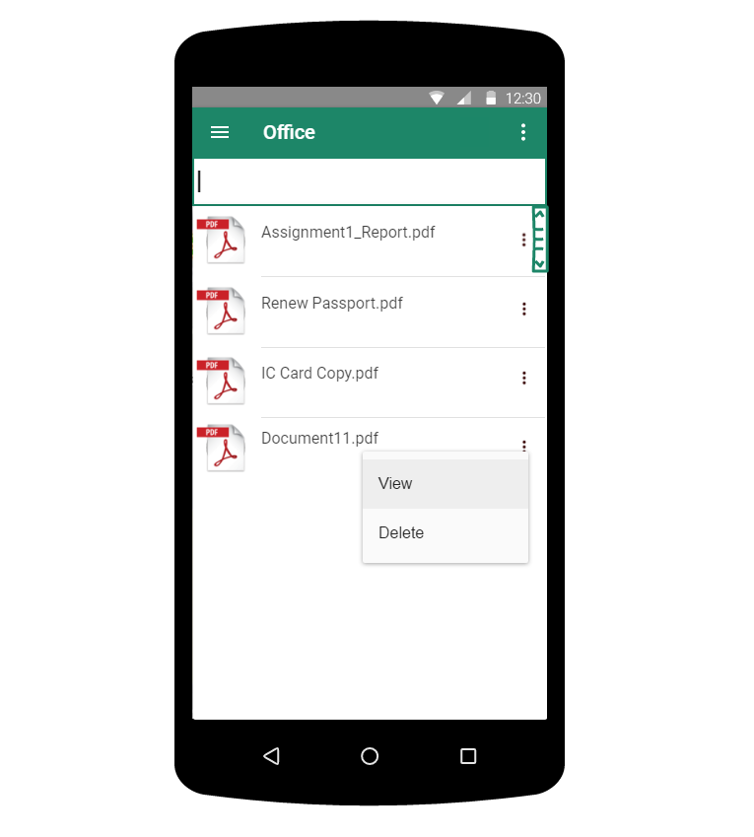

On clicking the 3 dots the a menu will drop down asking if they wish to view the file or delete the file.

## PDF viewer

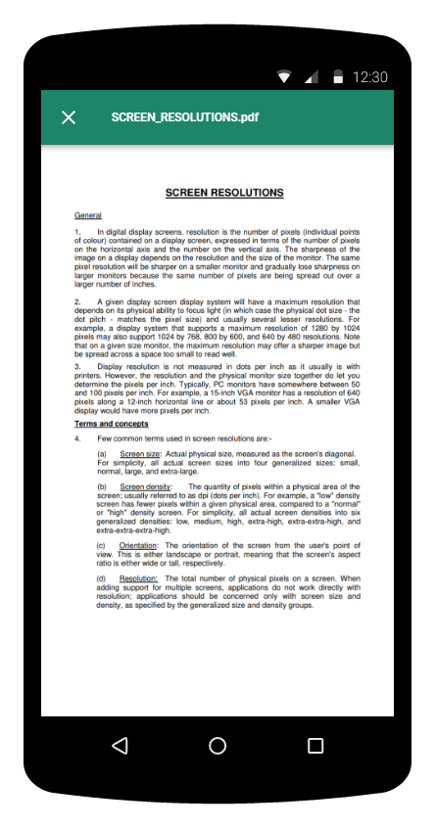

On clicking view in the former screen the application renders the PDF file and loads up on the screen.

## Main Menu

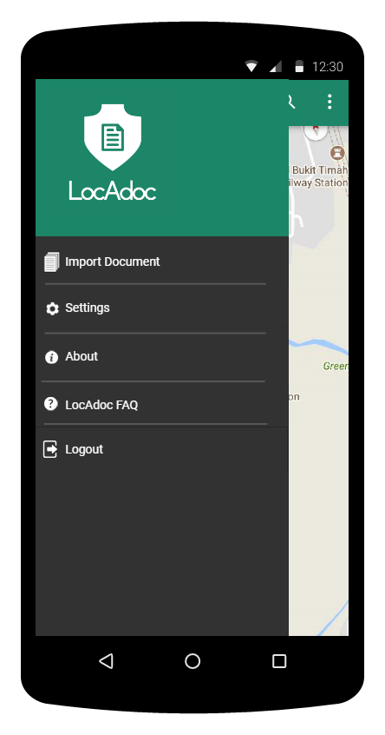

Main menu loads up when we click the icon on the main activity. It has options to add a new document, settings, about, a FAQ link and a logout option.

## Settings

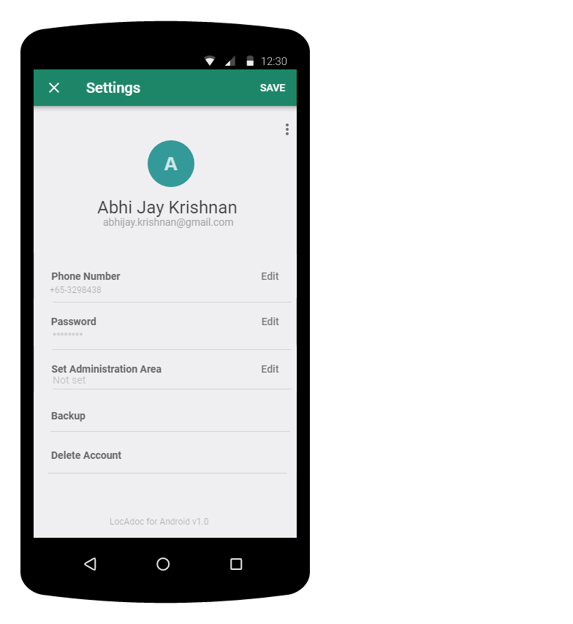

On this page, the user gets to edit his name and phone number. He may choose to back up his secured folder to AWS S3 by clicking on backup. The user may also wish to delete his account on which it will send the user back to login page. On clicking edit next to password will open a new activity.

## Change password

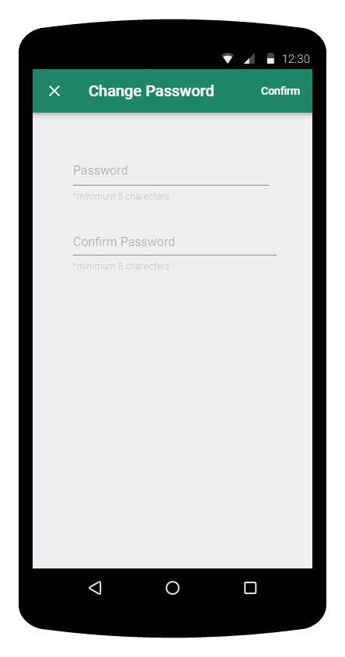

The user can change password by filling up the above form and clicking confirm on the top.

## About

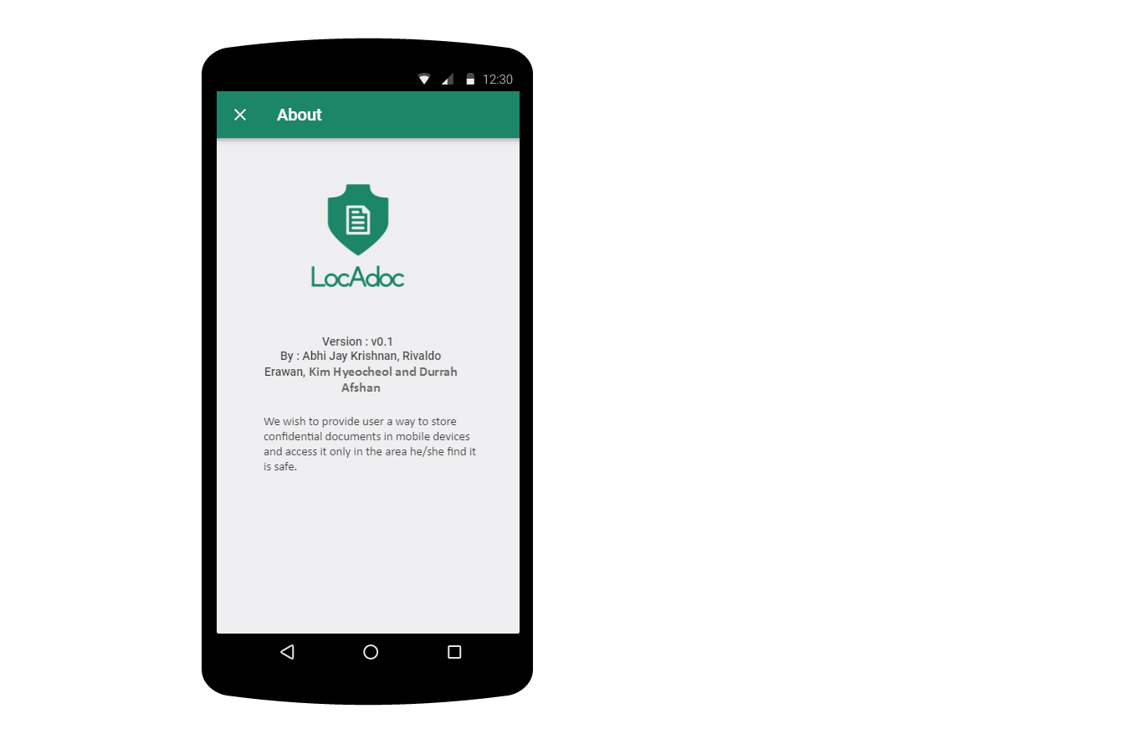

This activity can be reached from main menu and it describes the version of the application and credits.